19th November 2019

**WTCR Race of Macau heats up the Championship**

At Macau’s legendary Guia circuit, the Chinese manufacturer Lynk & Co, mastered a clean sweep winning the three races, and heated up the battle for the FIA WTCR World Touring Car Cup, which has Japanese premium tyre manufacturer YOKOHAMA as exclusive tyre supplier.

The Swedish team played a thorough strategy in favouring Yvan Muller, its best-placed driver in the Championship and after collecting valuable points being pole position he further raised his chances for overall glory with a dominant victory in Race 1 at the same time as adding important points in the other 2 races.

With the final race weekend left at Malaysia’s Sepang on December 13/15, Muller is now only 11 points behind the leader Norbert Michelisz and two points behind Esteban Guerrieri. Björk remains in contention as well with a gap of 28 points.

Muller’s four World Titles in touring cars signifies he has amassed a wealth of experience which may ultimately prove vital. For his part Guerrieri struggled with the speed of his Honda car, but was able to qualify 10th in the second session that meant pole position for Race 2. However, a decision from the Stewards resulted in a drop of three positions on the grid for impeding Nicky Catsburg during the first lap of the second Qualifying. The Argentine salvaged a fourth place in Race 2 and so retained the second position in the standings.

The other leading actors on the stage of the Guia circuit where Andy Priaulx and Kevin Ceccon. Priaulx claimed a brilliant lights-to-flag win in Race 3, providing the icing on the cake for Lynk & Co and returning to victory in Macau twelve years after he secured his third World Touring Car title. Ceccon emerged as one of the fastest drivers in the Asian street circuit and collected well deserved third places in the first two races.

Driver Championship standings

1. Michelisz 316

2. Guerrieri 307

3. Muller 305

4 Björk 288

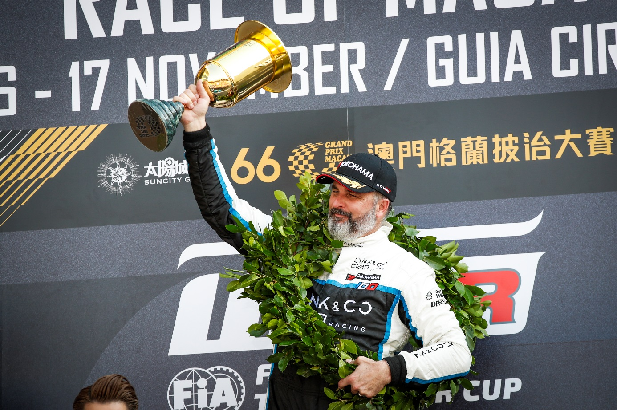

*Yvan Muller victory in Macau keeps him on the title race Pic Florent Gooden DPPI*

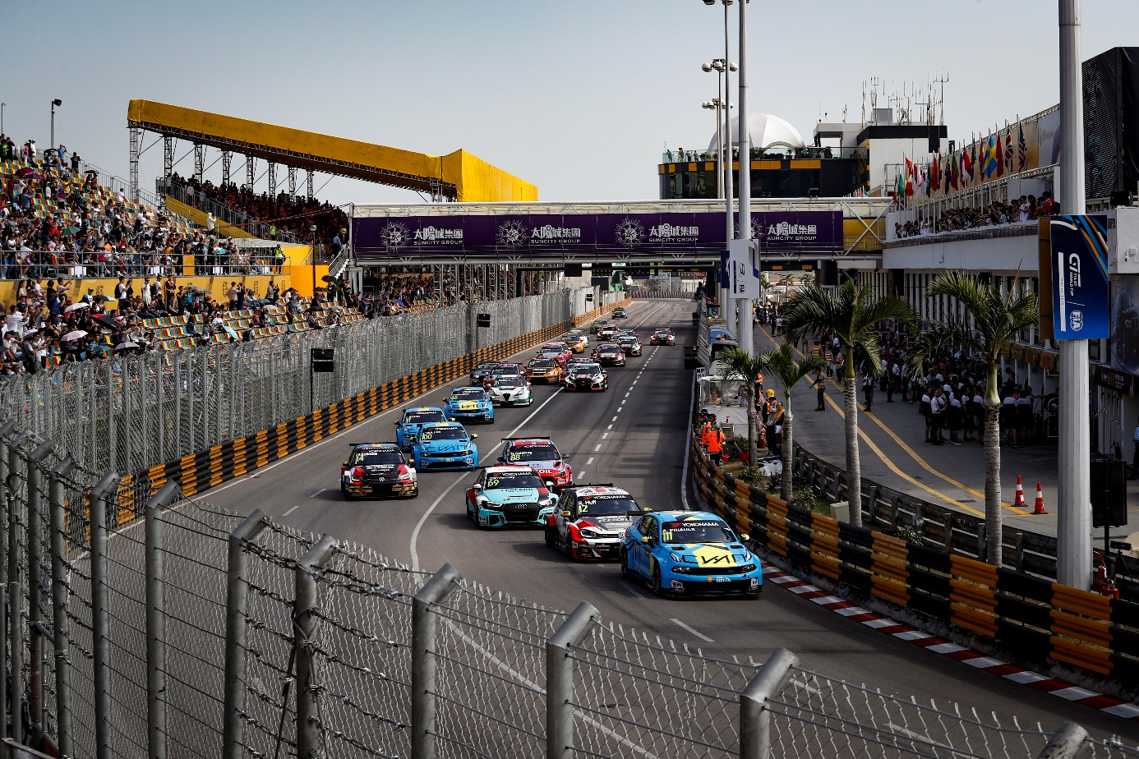

*WTCR 2019 Excites the crowd in Macau Pic by Clement Marin DPPI*